# ASSIGNMENT-7

**Title** : Implementation of primary and composite linguistic fuzzy variables

**Theory**  : The concept of linguistic variables was proposed by Zadeh as an alternative approach to modelling human thinking-an approach that,in an appropriate manner,serves to summarize information and express it in terms of fuzzy sets instead of crisp numbers.

A linguistic variable is characterized by a tuple (x , T(x) , X , G , M) in which

x 🡪 name of the variable

T(x) 🡪 term set of x (i.e. set of its linguistic values or linguistic terms)

X 🡪 universe of discourse

G 🡪 syntactic rule which generates the terms in T(x)

M 🡪 semantic rule which associates with each linguistic value ,say A,its meaning M(A)

Example

If ‘age’ is interpreted as a linguistic variable,then its term set T(age) could be like,

**T(age)**={young,not young,very young,not very young,middle aged,not middle aged,old,not very old,…………}

Where each term in T(age) is characterized by a fuzzy set of a universe of discourse **X**=[0,100].

The syntactic rule refers to the way the linguistic values in termset T(age) are generated.

The semantic rule defines the membership function of each linguistic variable of term set.

The variables like {young ,middle age,old} belong to class of **primary variables**.

The variables which are modified and linked by connectives such as and,or like {not very young **and** not very old } belong to the class of **composite variables.**

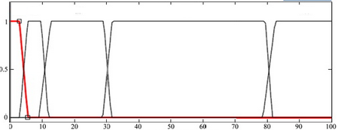age

Very very young 🡪 0 to 5 years

Very young 🡪 5 to 10 years

Young 🡪10 to 30 years

Middle aged 🡪 30 to 80 years

Very old🡪 80 to 100 years

**Concentration and Dilation of linguistic variables**

Let A be a linguistic variable characterized by a fuzzy set with membership function **𝛍a(x)**.Then

Ak =

We can say that,

Con (A)=A2 will denote concentration

Dil (A)=A0.5 will denote dilation

|  |  |
| --- | --- |
| **Hedges** | **Operation** |
| Very | A2 |
| Very very | A4 |
| Plus | A1.25 |
| Slightly | A0.5 |
| Minus | A0.75 |

**Intensification**

It increases the degree of membership of those elements in the set with original membership values greater than 0.5 and it decreases the degree of membership of those elements in the set with original membership values less than 0.5.

“intensify” A = 2 μA2(y) for 0≤μA(y)≤0.5

1 - 2[1- μA2(y)]2 for 0.5≤μA(y)≤1

*repeated application of “intensify” reduces the fuzziness of set..\in extreme case,fuzzy set becomes a crisp set.

**FAQ’s:**

1. Define a fuzzy set.
2. List various operations of on fuzzy set.
3. List the set operations which are voilated in fuzzy set theory